What are Benefits?
- A positive outcome to the business or stakeholders from undertaking a project or program.
- In the context of programs and projects, benefits are the measurable enhancements or advantages to an organisation, given its vision, mission, values, objectives and strategies.
- Benefits must employee SMART goal setting principles (Specific, Measurable, Achievable, Relevant, Time bound)
- You must have a Benefit Owner, Benefit reporter, stakeholders who experience the benefit and a metric using SMART to measure success
- Benefit plan must outline the activities to realise benefits
To whom does it apply?
Project Sponsors - Project Owners - Steering Committees – CMG – Senate - Project Managers - Project Teams
It is also offered as a framework for academic and research projects but is not mandatory for this classification of project.
Key Responsibilities for Benefits?
 | Responsible | Accountable | Consulted | Informed
Delivery of benefits | Owner | Sponsor | PM | Stakeholders
Change Management Planning | Owner and Change Manager | Sponsor | SME | Impacted Stakeholders
Reporting of Benefit Realisation | Benefit owner, Benefit Tracker | Sponsor | SME | Stakeholders
Risk mitigation around benefit risk | Benefit Owner | Sponsor | Risk Advisor, Control owner | stakeholders

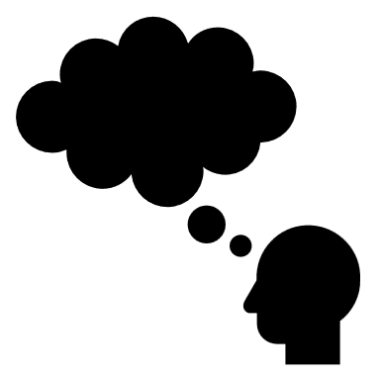 What are SMART Goals?
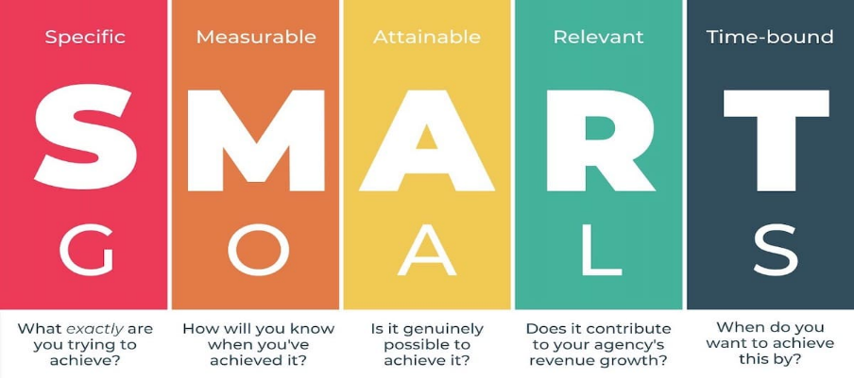
What are the must haves for benefit realisation?
Key artefact
Embed Change to make benefits enduring
The discipline to continually review benefits at each stage
Our Method using SMART

What is UQ’s benefit realisation framework?
Our framework for Benefit realisation is captured like this:
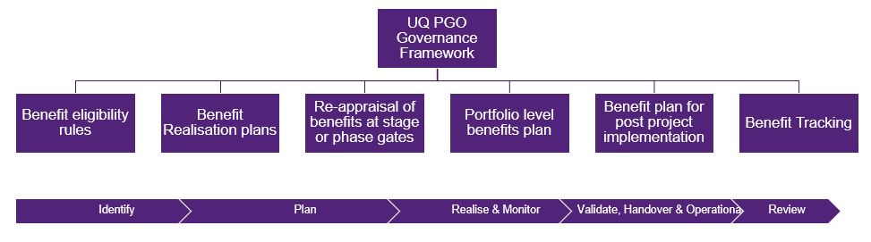
Which aligns to our project governance management framework lifecycle for projects.
Throughout the lifecycle, the benefit owner must be diligent around benefit targets and benefit tracking to establish if benefit realisation has been achieved and met targets.
What role does the PGO play regarding Benefit Realisation
At each stage of the project Lifecycle, projects will require PGO oversight to ensure we are setting up benefit realisation for success.
- At Identify Stage – the PGO provides guidance and support for identifying, setting appropriate targets (benefit metrics tree).
- At Identify Stage – we examine, challenge and provide assurance around benefit targets outlined in EOI’s and business cases
- At Plan stage – We ensure the Benefit Realisation Plan is well considered, apply the right articulation of the benefit and how the benefit will be realised as well as change plans to support benefit realisation
- At Plan to execute stage – we reappraise the benefits and consider if there are risks, or changes to delivery that results in a dis-benefit or benefit degrade
- At realise and monitor stage – we report to CMG and upwards the portfolio benefit profile and outline the progress of our major projects in pursuit of benefit realisation
- At validate - handover and operational stage – we ensure there is an adequate handover to ensure benefits are enduring into BAU transition
- At Review – We track benefits till Full Run Rate achievement of benefit realisation is achieved
How Change plays a part in benefits
Change management planning goes hand in hand with benefit planning and delivery planning.
As the solution is planned through delivery planning, while benefits planning is being considered and while execution is occurring, change planning must assess the complexity of change consider the change approach through a change impact assessment tool and articulate change through the PMP and benefit realisation plan.
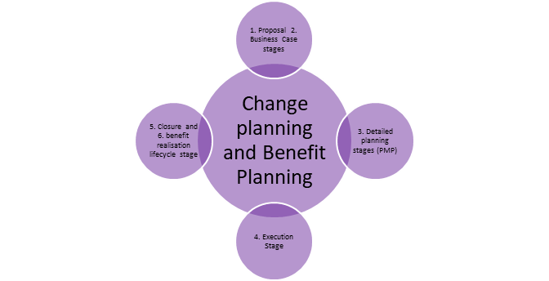

Strongly recommended
https://www.pmi.org/learning/library/benefits-management-accelerate-value-delivery-5959 (Strongly recommended background and best practice under PMI)
https://www.pmi.org/-/media/pmi/documents/public/pdf/learning/thought-leadership/benefits-realization-management-framework.pdf (Strongly recommended template under PMI)
https://www.youtube.com/watch?v=hfpEPdCwwQY (Strongly recommended presentation by PMI UK)

Useful resources
https://www.apm.org.uk/resources/what-is-project-management/what-is-benefits-management-and-project-success/ (High level how to guide)
https://www.pm-partners.com.au/why-your-organisation-needs-better-benefits-management-and-how-to-improve-your-practices/ (Recommended how to)
https://prince2.wiki/management-products/benefits-management-approach/ (useful reference with European PRINCE2 application)

application)

Crash Courses
https://www.youtube.com/watch?v=NC8WrPFyoeE (Crash course introduction to benefits)
https://www.youtube.com/watch?v=UxJb40pAnac (PMI benefit explanation)

Who is there for advice?
The PGO
Angela Bushell (Manager of Project Governance),
Joe Stanley (Senior Manager of Project Governance)
Daphne Drewes (Associate Director of PGO)
Functional PMO – ITS, Property and Facilities

Benefit Realisation additional resources
Change Management that enables Benefits Realisation
https://www.youtube.com/watch?v=Xt-eUlYYawM (Strongly recommended to understand how Change Management enables Benefit Realisation)

