[Guideline Title]
A guideline is a document that provides general statements, recommendations or administrative instructions designed to achieve the objectives of a legal instrument, policy or procedure. They are often statements of ‘best practice’ or provide advice on the application of a policy or procedure. Guidelines are not mandatory and are advisory only. Unlike policies and procedures, the format for section headings and sub-headings in this template can be adapted and changed (except for “Purpose and Scope” and “Meta Data for Document Management”).
- Headings and styles for use
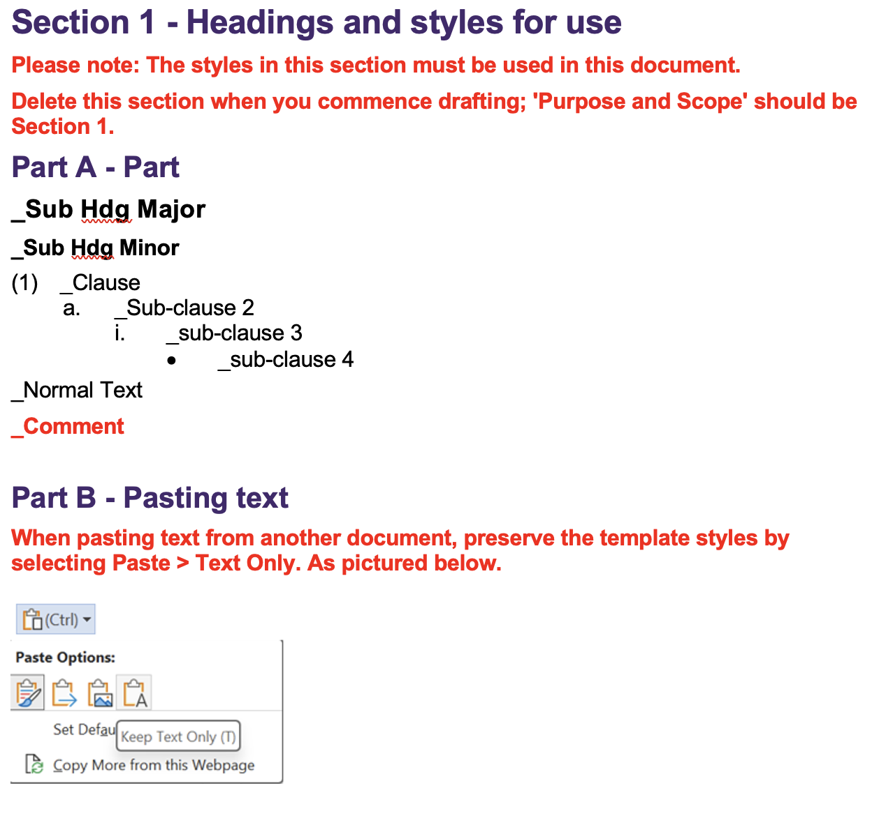
- Purpose and Scope
- State the objective/s of the guideline, outline of the subject matter covered in the guideline and to whom or when the guideline applies. Include reference to relevant legal instrument, policy and/or procedure the guideline gives effect to.
- Appendix
- If deemed necessary, use the appendix to:
  - List terms and acronyms used in the guideline and their definitions. If only a few terms and acronyms are used, they may be listed and defined in the body of the guideline, as appropriate.
  - Provide additional information necessary for the reader to better understand the guideline.
- Ensure any appendices are properly referenced in the guideline.
- Meta Data for Document Management
Correct meta data must be supplied for the document to be published and to enable effective document management.
Metadata
Associated Information
(e.g. links and explanations)
Area of responsibility | [e.g. Directorate, School, Business Unit, etc]
Policy Owner | [Position]
Unit Head
(person reporting to policy owner)
Document Author
(person writing the document)
Enquiries contact
(at business area level,
if different from area of responsibility)
Document Category | Select applicable from list
Document Realm | Select applicable from list
Target Audience  (select all applicable) | ☐ Staff | ☐ Students | ☐ Community
Next review date  (generally five years from approval date unless required sooner) | [list frequency of review cycle, e.g., 3 years, 5 years; or, list particular date if applicable]
Change summary
Amendment summary
(Briefly describe the changes. This commentary will be visible to all PPL users)
Consultation outcomes
(where undertaken)
Issues of note
(where applicable)
Other Notes

