[Policy Title]
Other than the headings and the Meta Data Document Management table in Section 7, all other text is for guidance only and should be removed from the final policy.
- Headings and styles for use
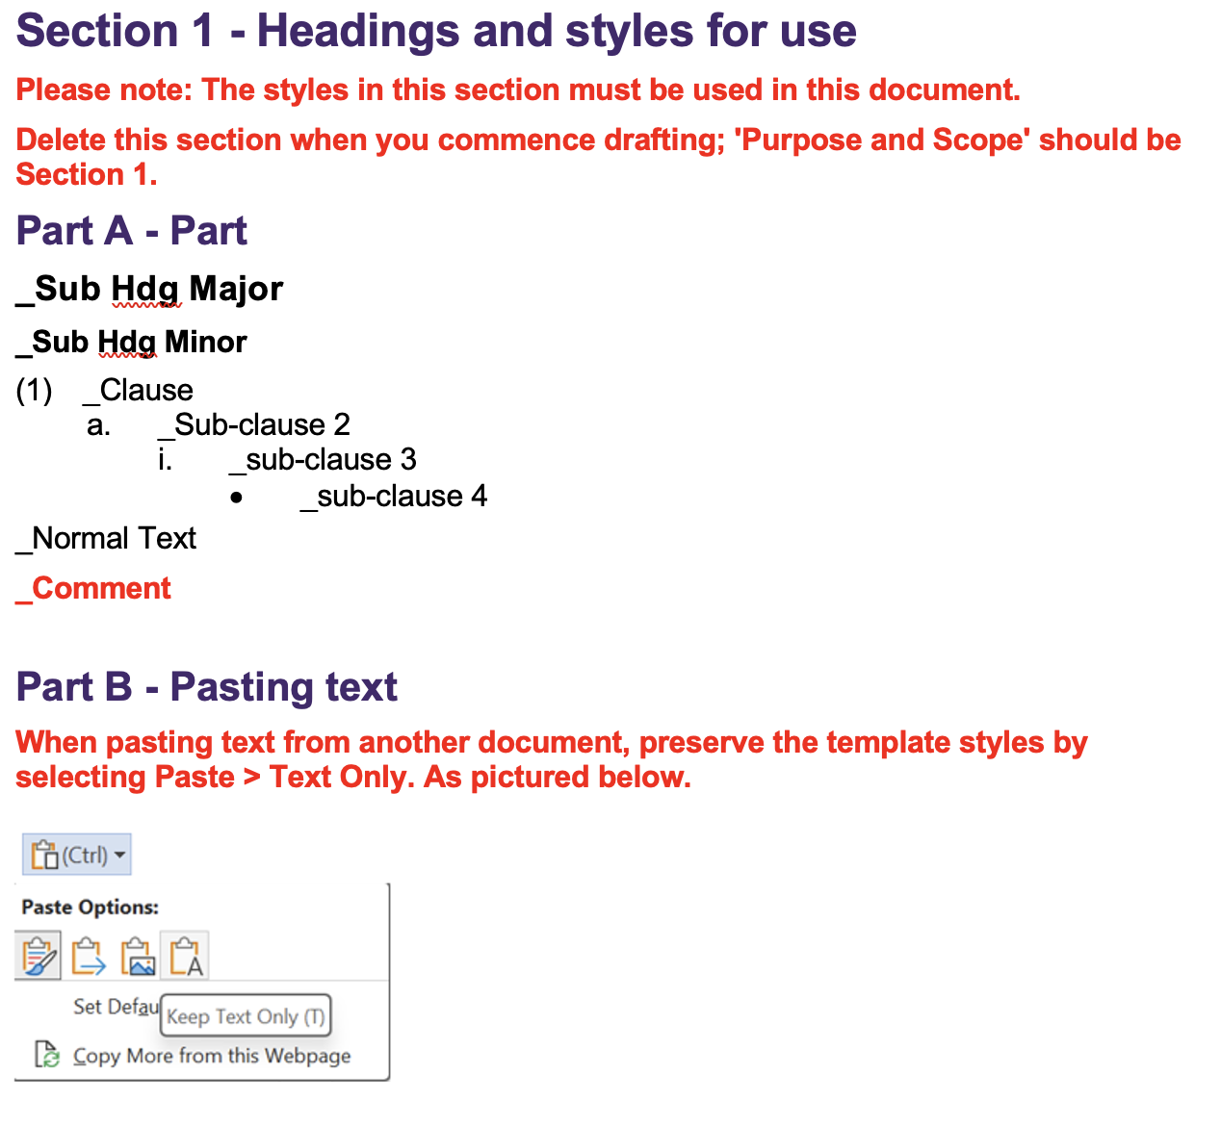
- Purpose and Scope
- Ensure the following:
  - The policy outcome and output expectations are clearly stated together with the University’s position and/or objective on the subject matter (if Policy).
  - The policy objective and scope is reasonably precise, and consistent with, but not unnecessarily duplicating, other policies and procedures.
  - It is clear to whom the document applies; exclusions have been identified and justified.
  - The Policy evidently has one or more of the following purposes:
    - To support the achievement of the University’s approved objectives and strategic priorities;
    - To give effect to directions or advice from the Senate, the Vice-Chancellor and President or the Academic Board (subject to approval from the Vice-Chancellor and President);
    - To manage risk/s of strategic significance; and/or
    - To demonstrate compliance with laws, regulations, mandatory government policies/standards, legal obligations and/or mandatory professional standards.
- Principles and Key Requirements
- Ensure the following:
  - All Principles and Key Requirements align with the policy objectives and scope.
  - All actions, outputs and outcomes resulting from the Principles and Key Requirements are verifiable.
  - All key requirements are principles-based.
  - The Principles and Key Requirements of the policy state WHAT objectives and outcomes are to be delivered and WHY.
  - All Principles and Key Requirements are stated concisely and precisely.
  - The merits of each of the Principles and Key Requirements are obvious and convincing and provide sufficient justification for them to be mandatory across UQ.
- Roles, Responsibilities and Accountabilities
[This field is optional]
- Ensure the responsibilities and accountabilities of the key roles affecting or affected by the policy (those involved in the development, implementation and management of the policy and the delivery of the outputs and outcomes) are clearly stated in simple, easy to understand terms and are action-oriented.
- Monitoring, Review and Assurance
- Ensure that it is clear what monitoring and review activities will be undertaken and by whom to:
  - Assess compliance with the policy and to demonstrate/confirm its effectiveness.
  - Identify, assess and promptly address any deficiencies.
  - Ensure ongoing relevance of the policy.
  - Report on the outcomes of those activities to senior management.
- Appendix
- If deemed necessary, use the appendix to:
  - List terms and acronyms used in the policy and their definitions. If only a few terms and acronyms are used, they may be listed and defined in the body of the policy, as appropriate.
  - Provide additional information necessary for the reader to better understand the policy.
  - Ensure any appendices, including mandatory forms, are properly referenced in the policy.
- Meta Data for Document Management
Correct meta data must be supplied for the document to be published and to enable effective document management.
Metadata
Associated Information
(e.g. links and explanations)
Area of responsibility | [e.g. Directorate, School, Business Unit, etc]
Policy Owner | [Position]
Unit Head
(person reporting to responsible executive)
Document Author
(person writing the document)
Enquiries contact
(at business area level,
if different from area of responsibility)
Document Category | Select applicable from list
Document Realm | Select applicable from list
Target Audience  (select all applicable) | ☐ Staff | ☐ Students | ☐ Community
Next review date  (generally five years from approval date unless required sooner) | [list frequency of review cycle, e.g., 3 years, 5 years; or, list particular date if applicable]
Change summary
Amendment summary
(Briefly describe the changes – this commentary will be visible to all PPL users)
Consultation outcomes
(where undertaken)
Issues of note
(where applicable)
Other Notes
Overall
- Ensure the policy passes all of the following tests:
  - It will enable prudent and timely decisions to be made and for University operations to be performed effectively and efficiently.
  - It focusses on delivering specific outputs and outcomes in a competent manner.
  - It provides clarity of roles, responsibilities and accountabilities.
  - It adopts a holistic and risk-based approach to the design and implementation of controls and for demonstrating compliance.
  - It enables, or at least does not restrict, automation and the innovative use of technology.
  - It incorporates management assurance protocols to monitor, assess and ensure that documented controls are effective, efficient, current and continuously improved.
  - It is based on the approved document template for policies and written in simple and easy to understand language.
- Also ensure the drafted policy sufficiently demonstrates its importance and makes a compelling case for its existence as a stand-alone mandatory document. Finally, ensure appropriate consultation has been/is being undertaken in the preparation of the policy.

